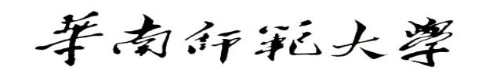

**Aberdeen Institute of Data Science and Artificial Intelligence, South China Normal University**

**Examination of 2022－2023 Academic Year Semester 1**

**Exercise Course of Advanced Mathematics II-1 Paper A**

**Answer Booklet and Marking Criteria**

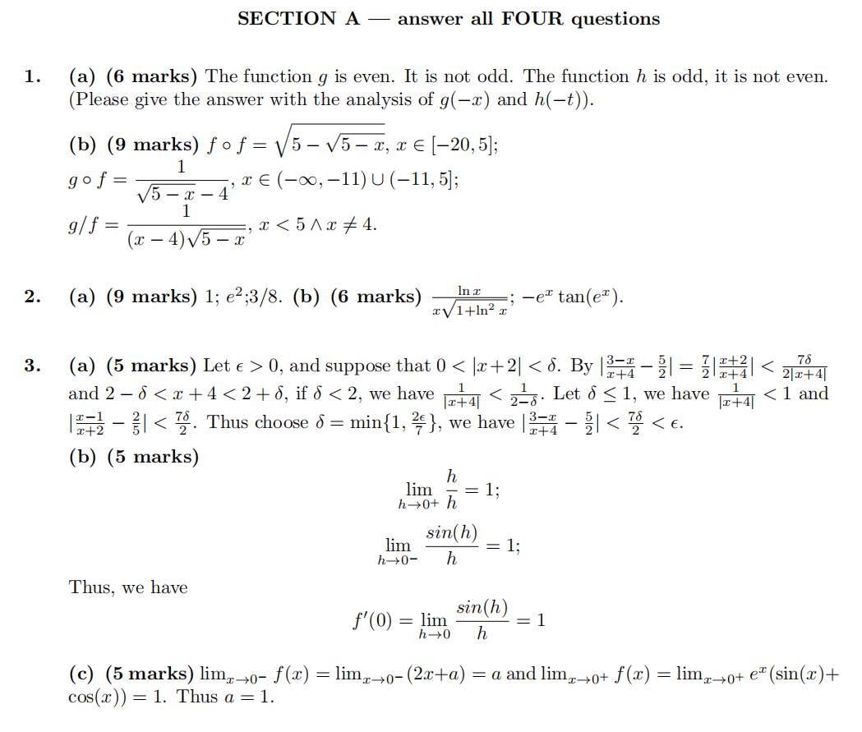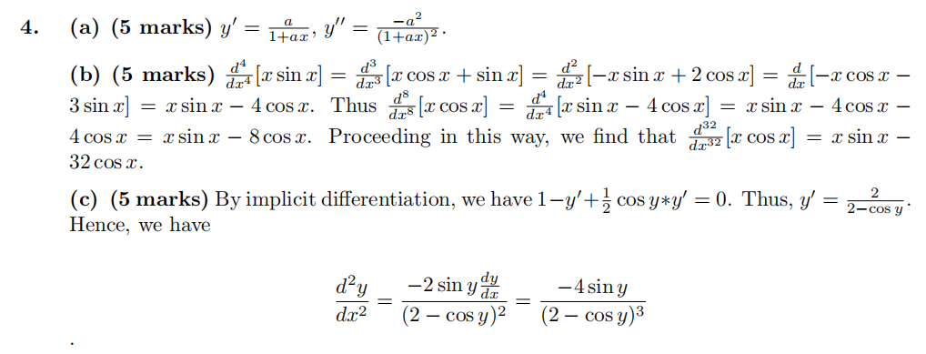

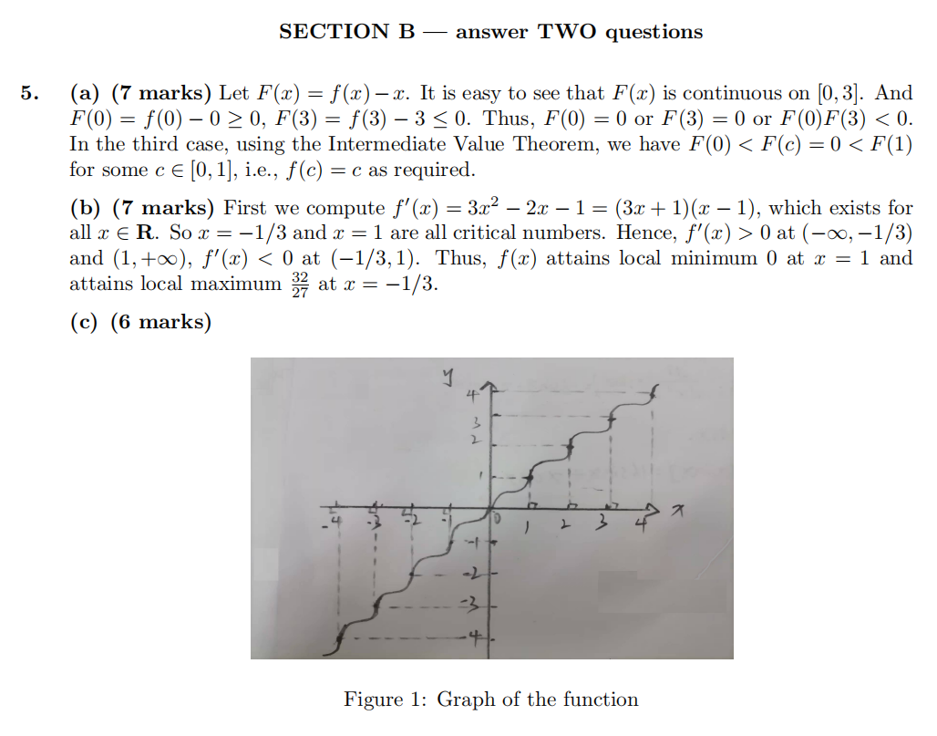

图x负半轴部分图像错误了，x负半轴部分的图像需要x轴对称到y的正半轴上面

