**正规课第5次作业主要错误点**

**Question 72**

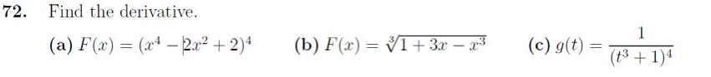

**主要错误：**

1. (c)项错误的同学较多。（1. More students made mistakes in (c).）

**Answer:**

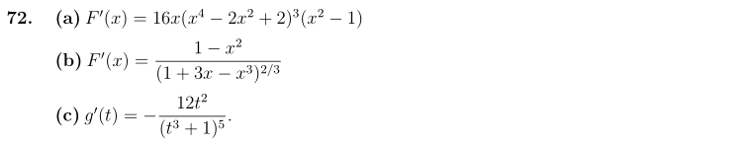

**Question 75**

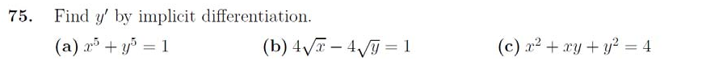

**主要错误：**

1. 大多数同学能正确求解此题。（Most students can solve this problem correctly.）

**Answer:**

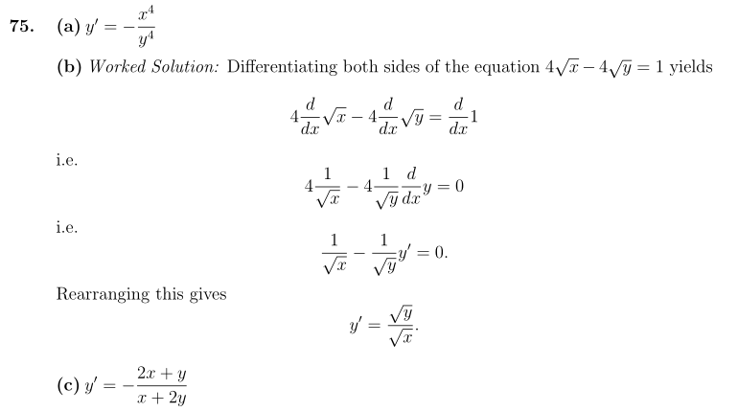

**Question 81**

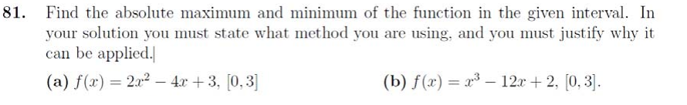

**主要错误：**

1. 大多数同学能正确求解此题。（Most students can solve this problem correctly.）

**Answer**:



**Question 85**

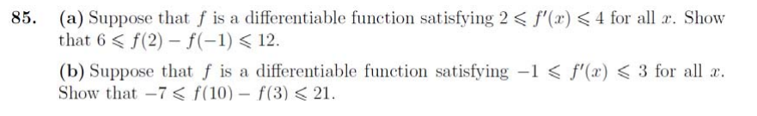

**主要错误：**

1. 此题有挺多同学不会证明。（Many students can't prove it.）

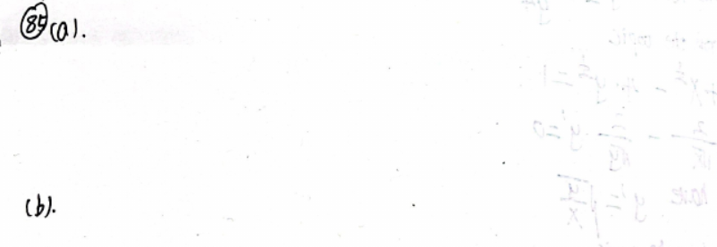

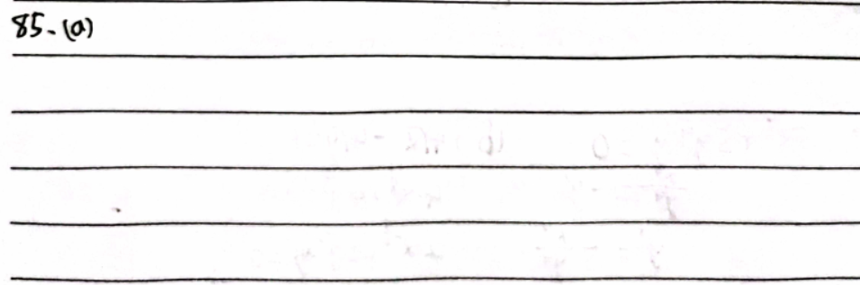

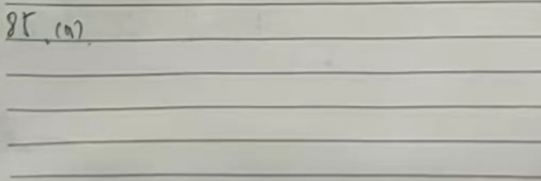

**Answer**:

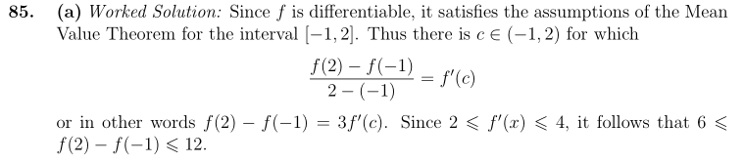

**Question 88**

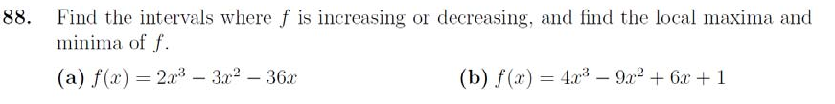

**主要错误：**

1. (b)项错误的同学较多。（More students made mistakes in (b).）
2. 有的同学不会求极值。（Some students can't calculate local maxima and local minima.）

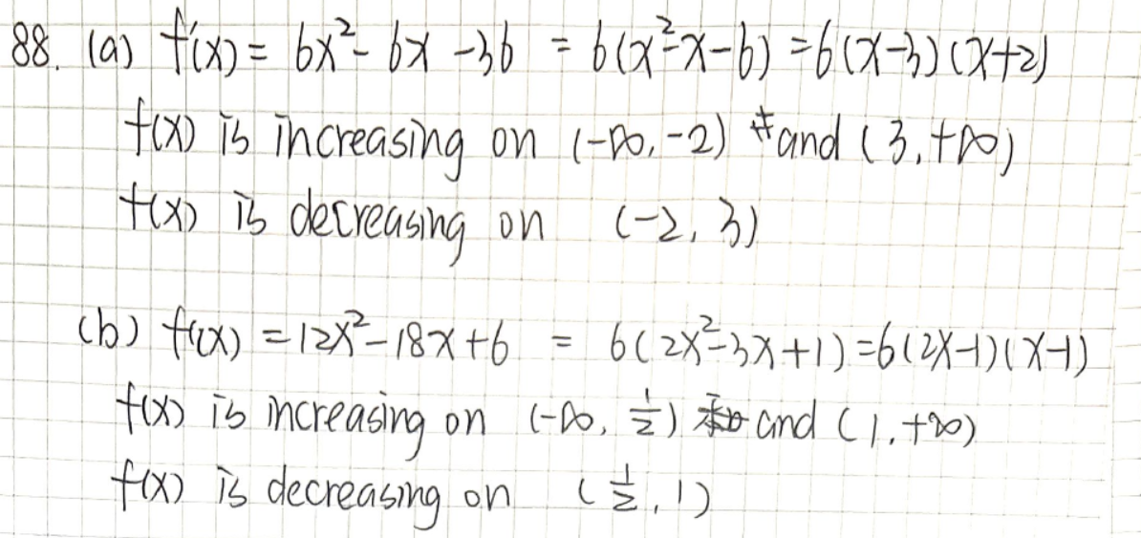

**Answer**:

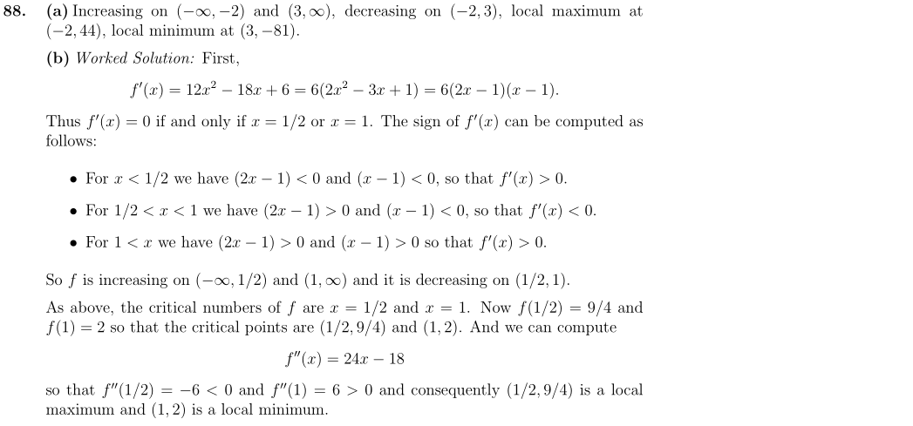

**Question 90**

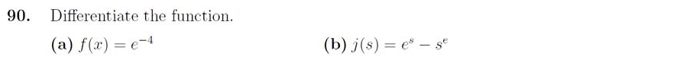

**主要错误：**

1. 很多同学直接不做此题。（Many students do not solve this problem.）
2. 个别同学容易这样求错。（Some students are easy to make mistakes like this.）

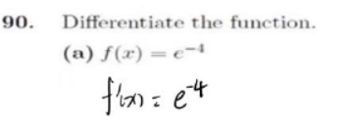

**Answer**:

