**习题课第6次作业主要错误点**

**Question 1**

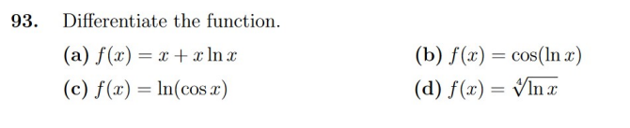

**issues：**

in question c，lot of students didn't correctly calculate the derivative of function by using derivation rule of composite function.

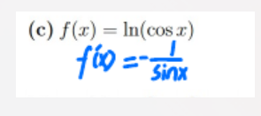

**Answer:**

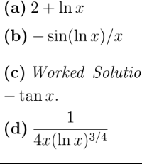

**Question 2**

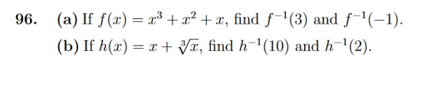

**issues：**

very few students regarded inverse function as reciprocal function.

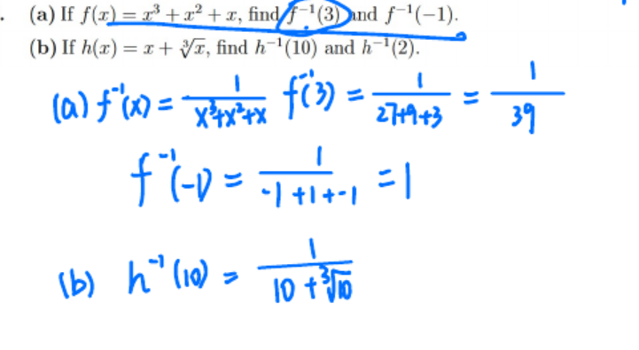

**Answer:**

