**习题课第1次作业主要错误点**

**Question 1**

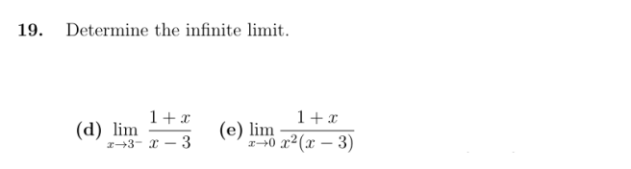

**issues：**

in the d question, some sort of students neglected x->.

in the e question, when x->0, then x-3<0, but lot of students hadn’t noticed negative value.

**Answer:**

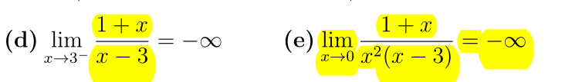

**Question 2**

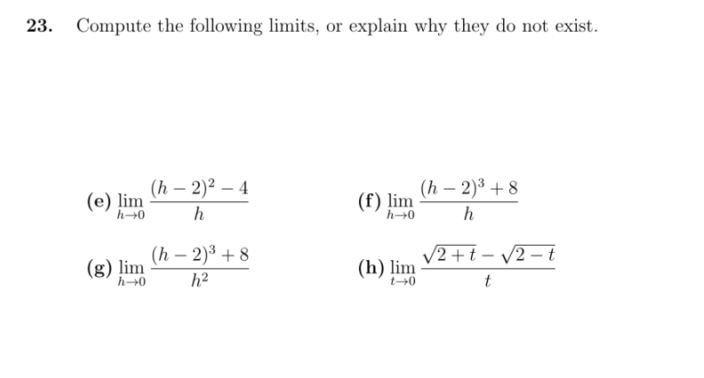

**issues：**

in the g question , This limit should be discussed in two situations, h-> and h->,but most of students just calculated the situation of h->.

**Answer:**

