**习题课第1次作业主要错误点**

**Question 2**

Sketch the graph of the given function.

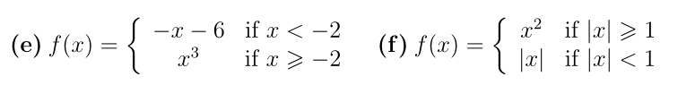

**issues：**

in the e question, some sort of students mistakes for or x.

in the f question, many students mistake the domain of definitionof piecewise function.

**Answer:**

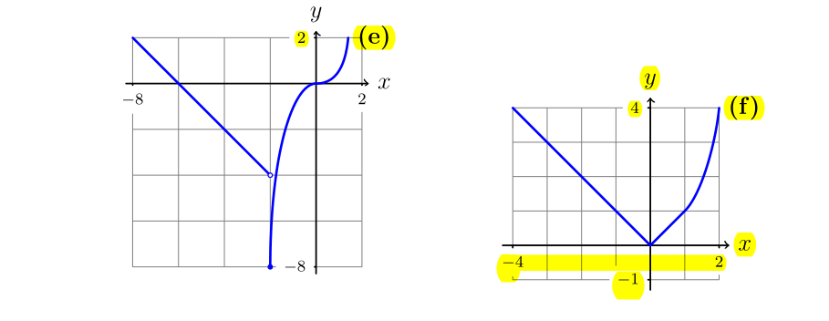

**Question 3**

Find expressions for the given functions, and state their ranges.

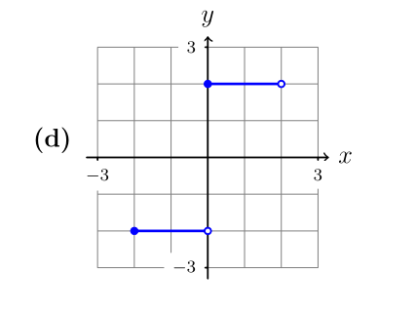

**issues：**

Many students forget to state ranges of function.

**Answer:**

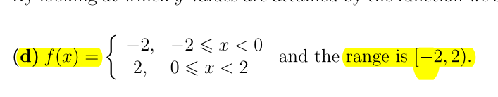

**Question 3**

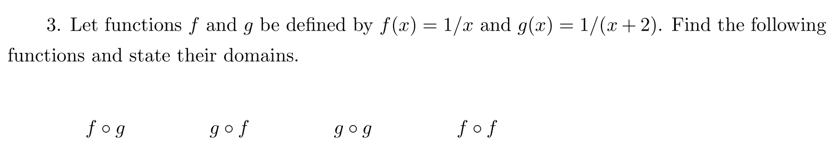

**主要错误：**

大部分同学能做对此题。

**Answer**:

